MIPS Cloud Smart Pass Simple Operation Instructions
- Enter the official website（http://www.mipsyun.com/）register an account.
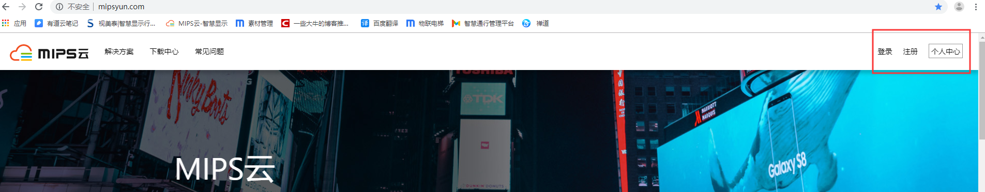
- Download Smart Pass(apk) in Download Center.
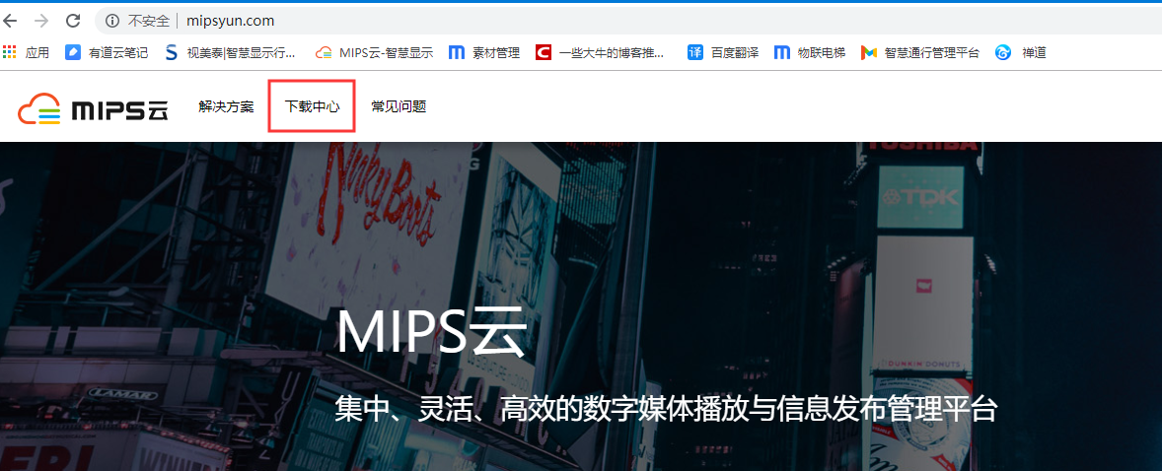
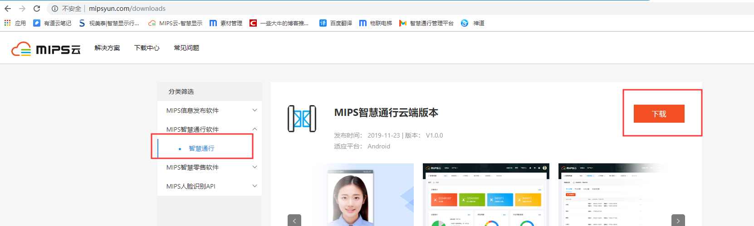
- After downloading the apk, copy it to a USB flash drive, install it on the device, and run it. Press the middle mouse button and type in the password 123456 to enter the setting interface. Click Login Management to log in the registered account password.

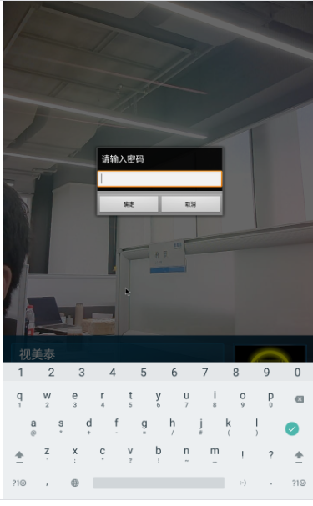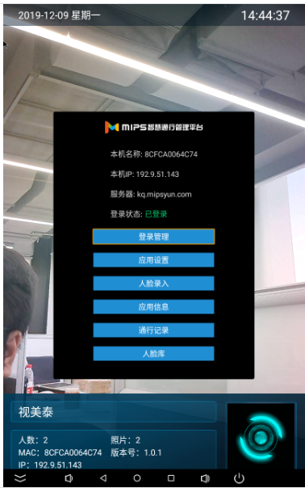
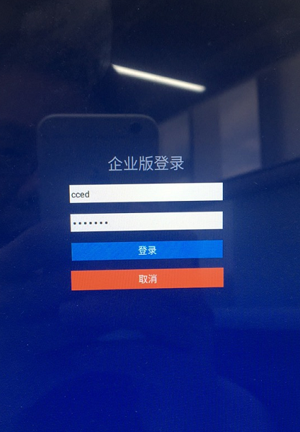
4. Log in to the MIPS cloud platform and click Smart Pass.
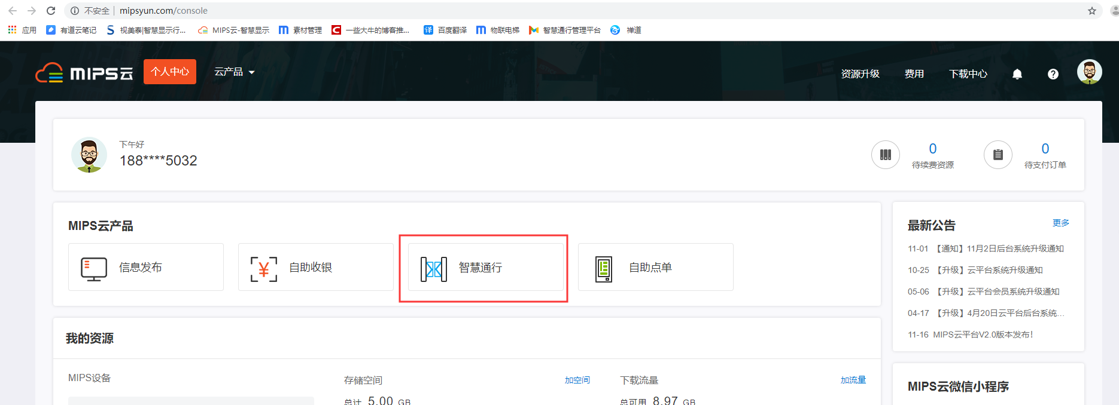
5.Create attendance rules.
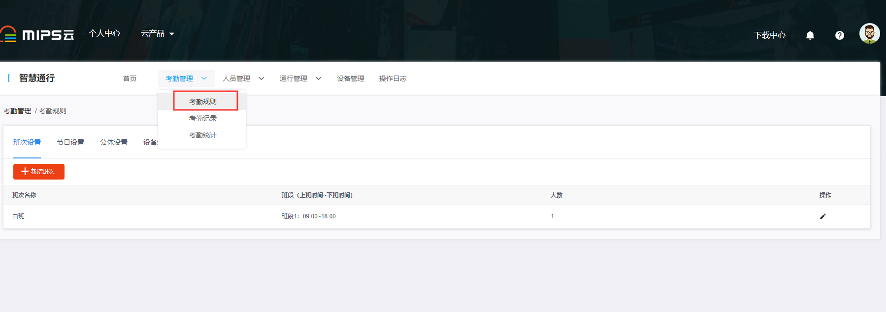
- Check attendance records and statistics.
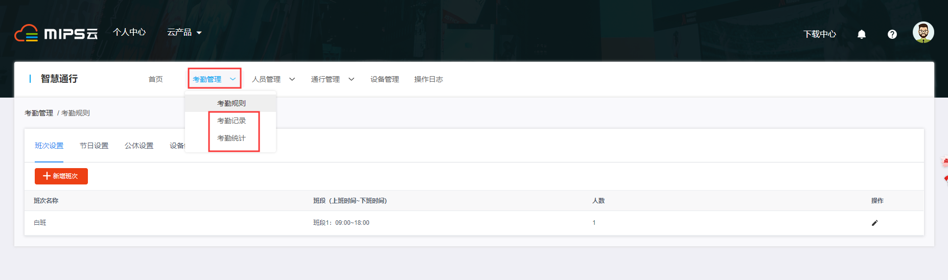
- Add employee (guest / blacklist) information.
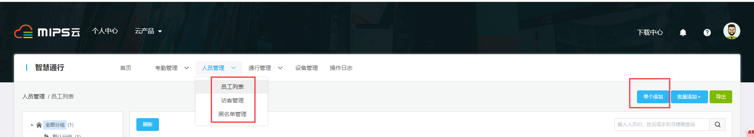
- Staff (guest) access authorization.
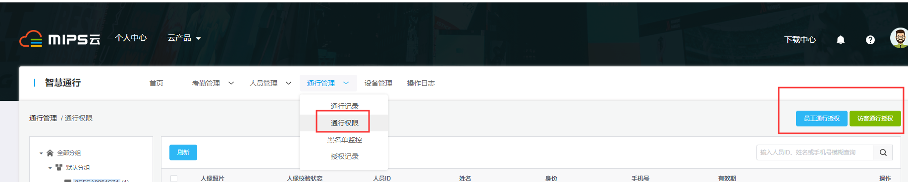

- Equipment management.
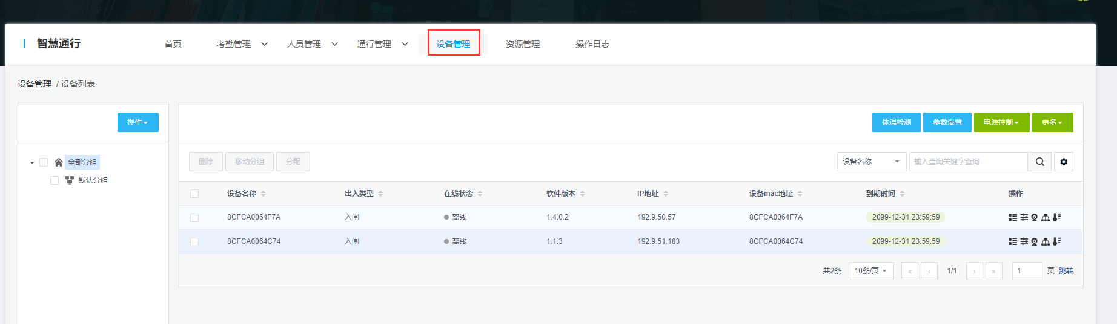
Body temperature detection setting
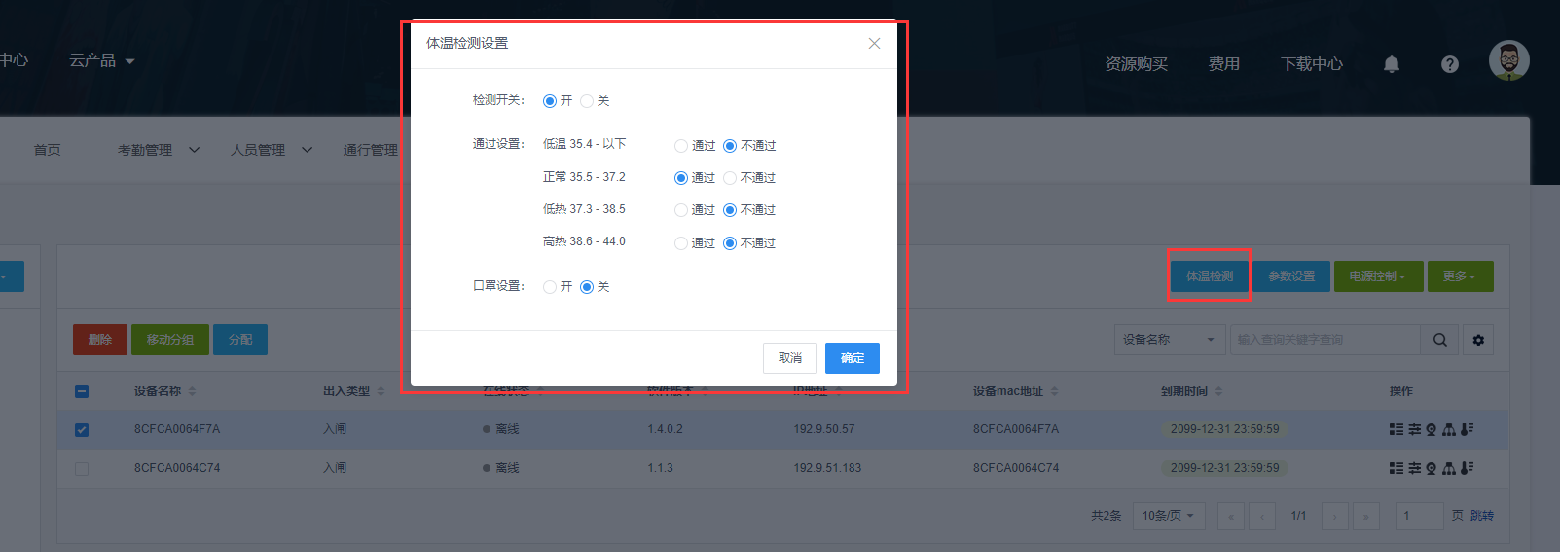
Parameter setting (can set company name)
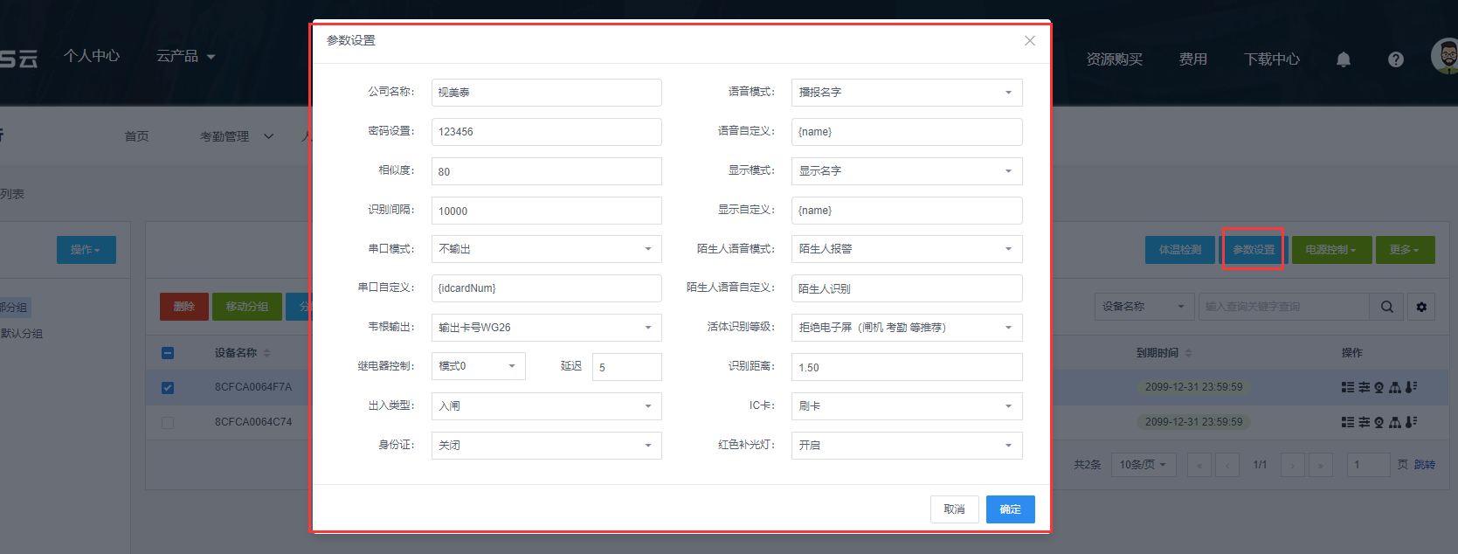
Client upgrade
