Brief function description of Smart Pass Temperature Detection APK

APK the main interface of running
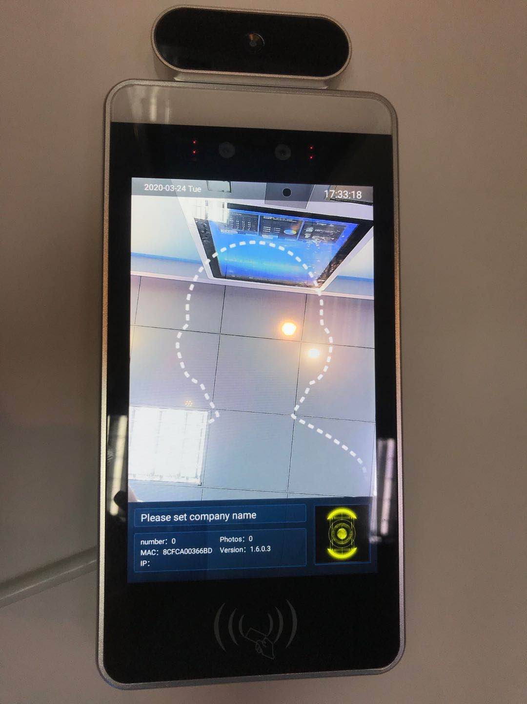

Setting interface
Press the mouse wheel button (middle button) and type in the password 123456 to enter the setting interface.

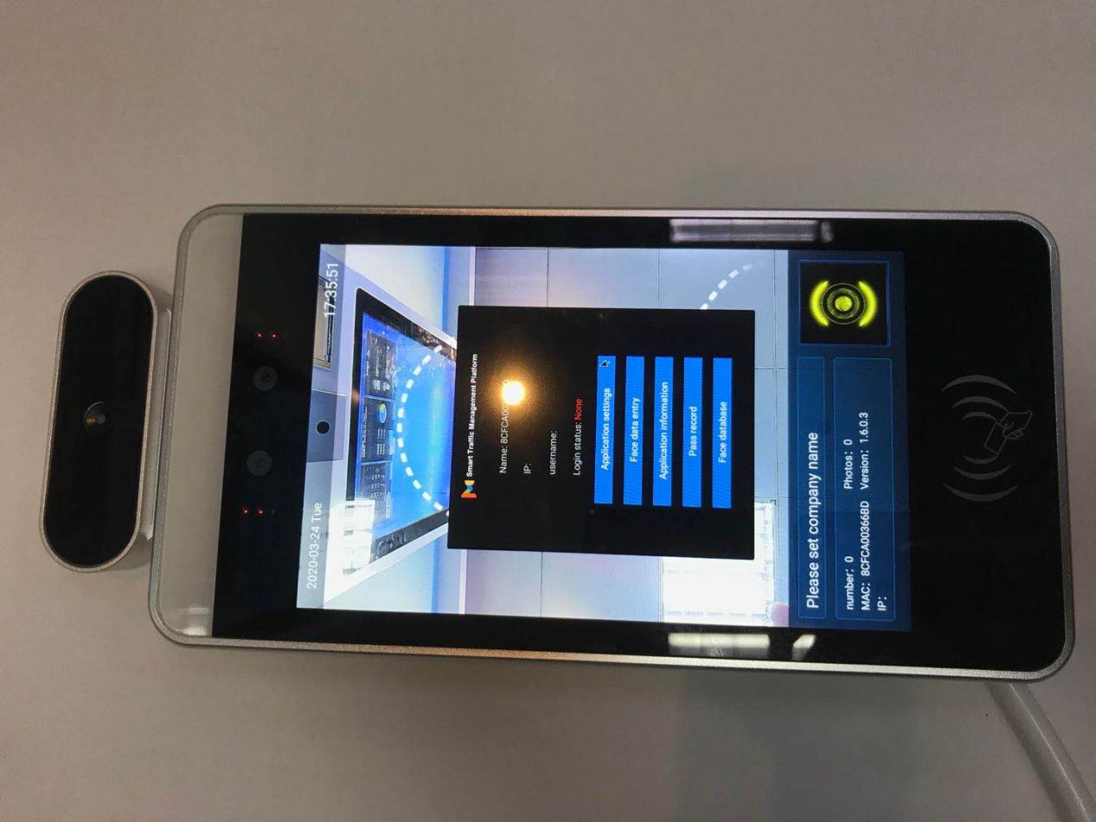

Login management
Need to register with our cloud platform（http://www.mipsyun.com/）, then fill in the account of the cloud platform on it to connect to the platform.
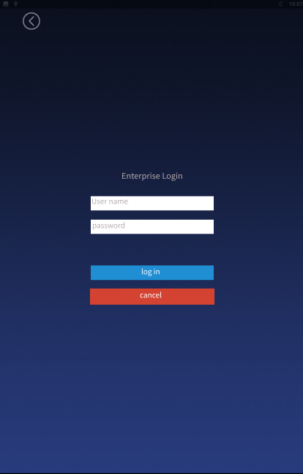

Application setting
- Device name setting: Set the device name.
- Body temperature setting: body temperature detection, body temperature alarm, mask detection function switch on and body temperature threshold value.
- Identification parameter setting: the lower the threshold value, the higher the identification accuracy, the more identification times, the slower the stranger is reported.
- Volume setting: set the volume
- Startup setting: Auto start after booting, and the application will start automatically after exiting.
- Identification effect display: setting of LED light, green light for success (settable display image name), red light for failure, fill light.
- Application password setting: set password, initial password is 123456.
- Camera preview resolution setting: Set the resolution.
- Screen saver brightness setting: set brightness.
- Device restart time setting: setting of device restart time.
- Relay setting: There are 3 relay modes. Mode 0 is non-automatic closing, and the signal to switch on and off is required. Modes 1 and 2 are automatically closed, as long as a signal to open the gate. 1 is high level, 2 is low level.
- Application initialization: restore the initial
.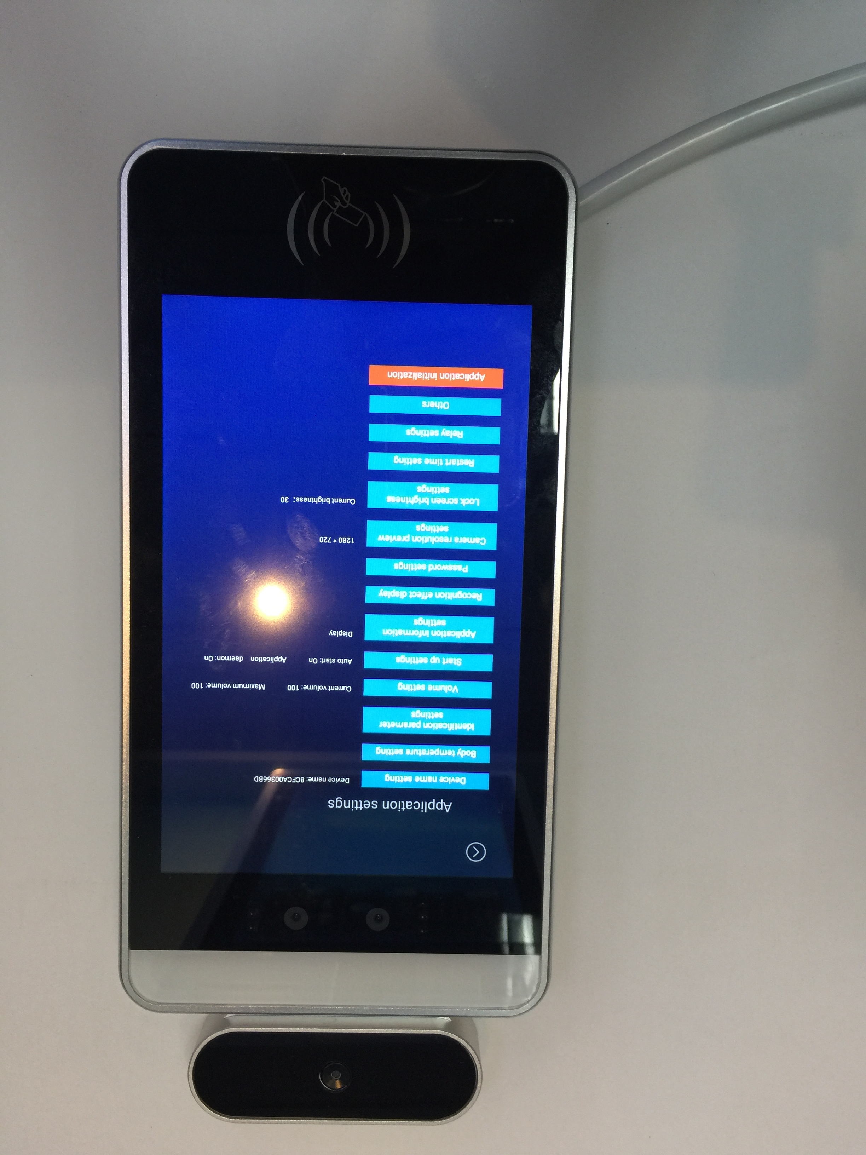

Face entry :Enter face information
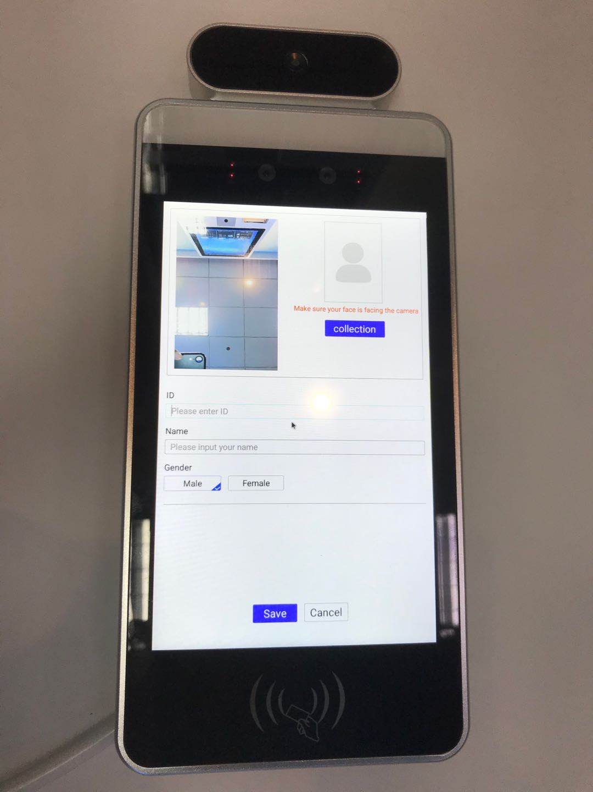

Application information: check the basic information of the device.

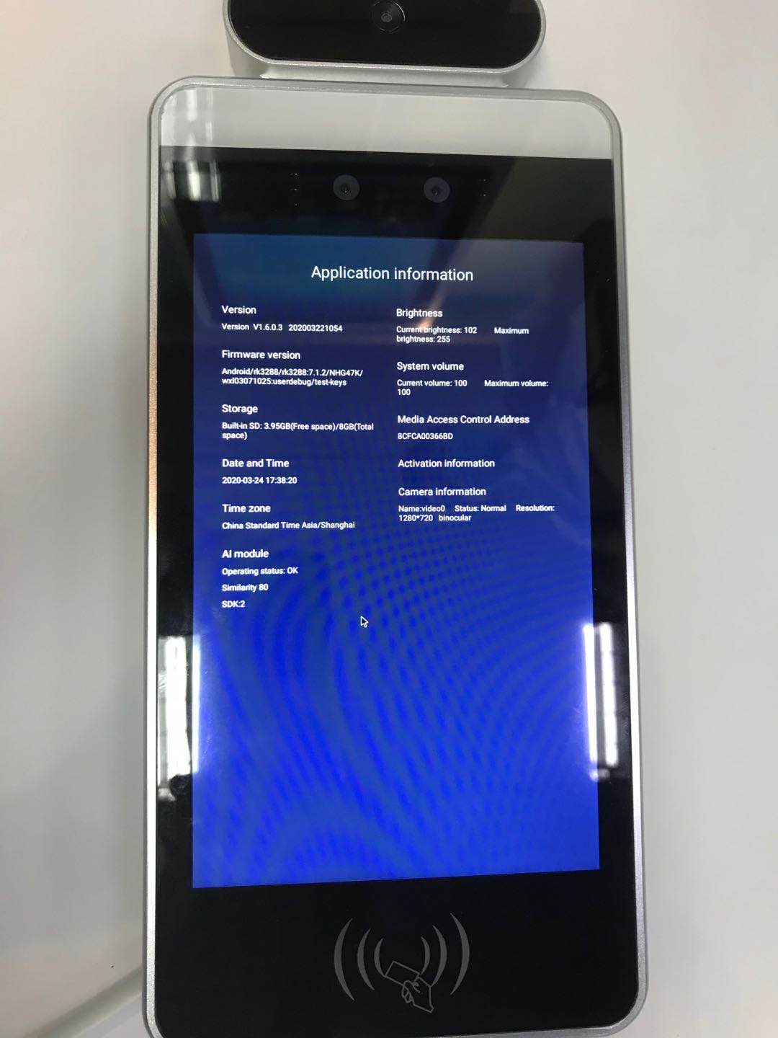

Pass record: save and view the information of brushed face.

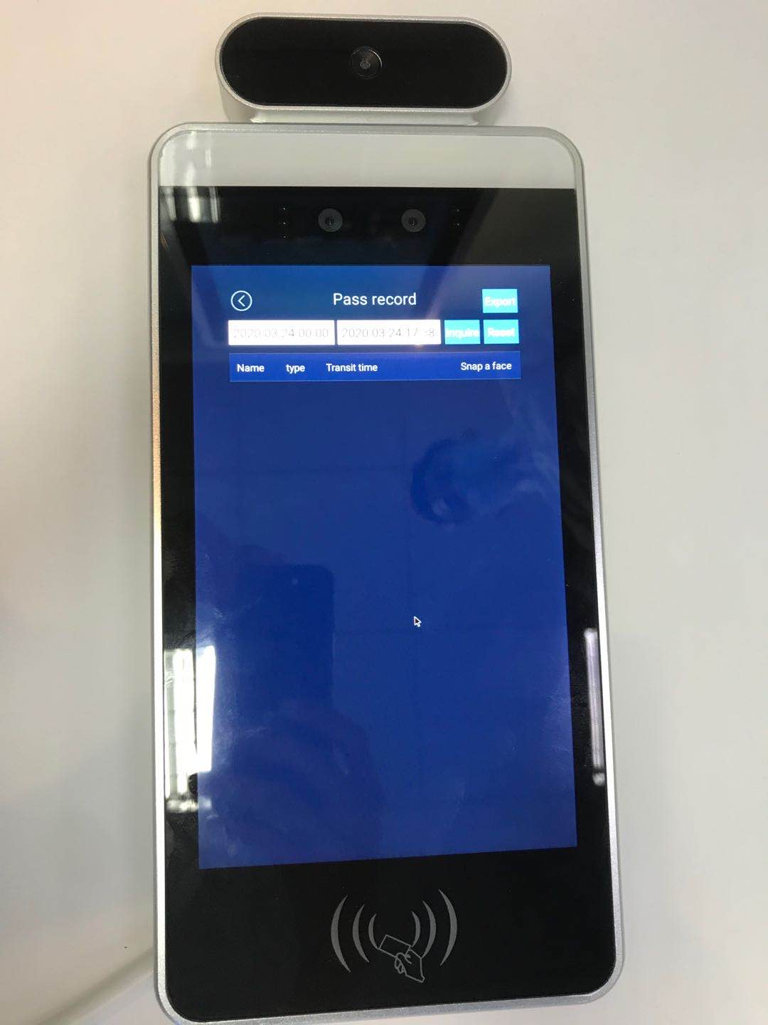

Face library: save the information of entered face.
